Lab Assignment 01 Worksheet

Part 1 Connecting to printers on campus (1 mark)
No screen shot required, print your demonstration sheet, and bring to lab for demonstration, the physical demonstration sheet itself is worth 1 point.

Part 2 Basic Operating System Maintenance (4 marks)
(2a) Screen shot showing operating system is updated:
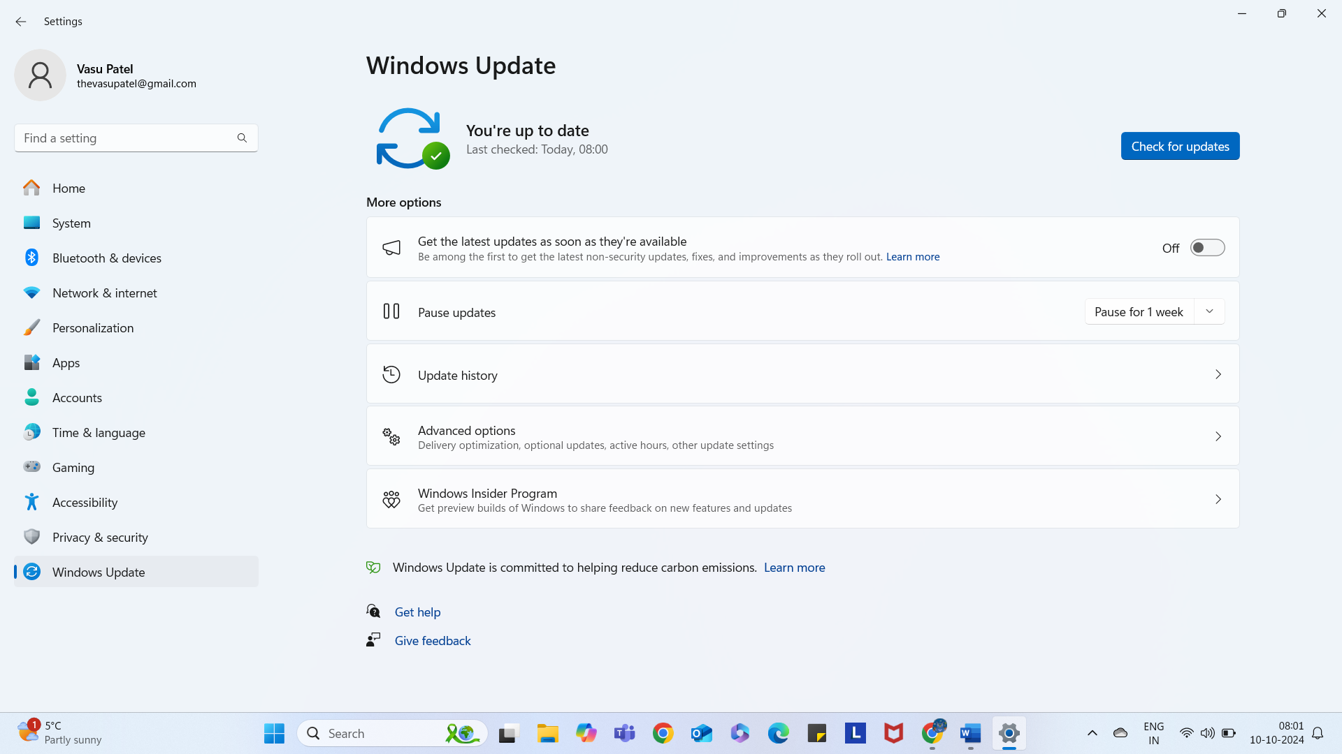

(2a) Screen shot showing antivirus is updated:
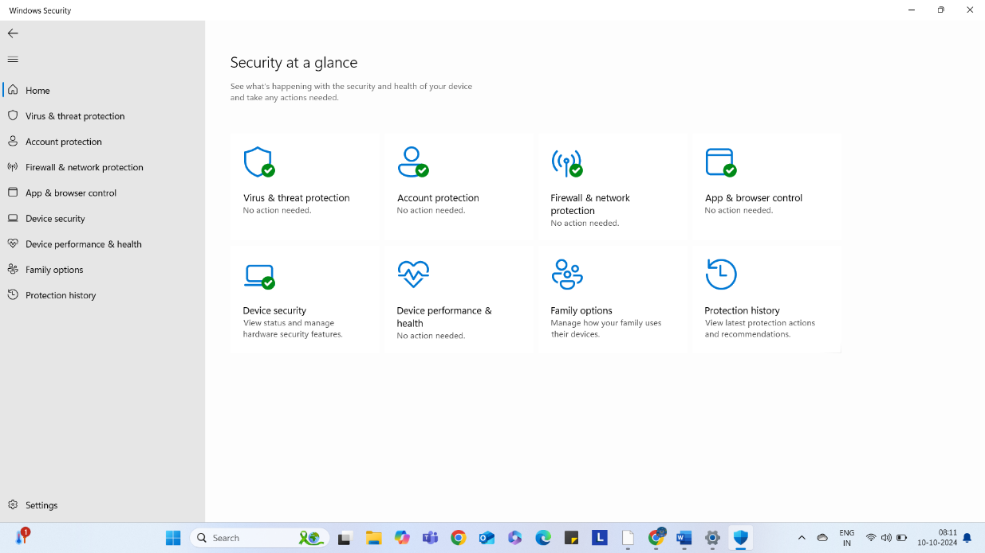

(2b) Screen shots showing use of ipconfig as requested
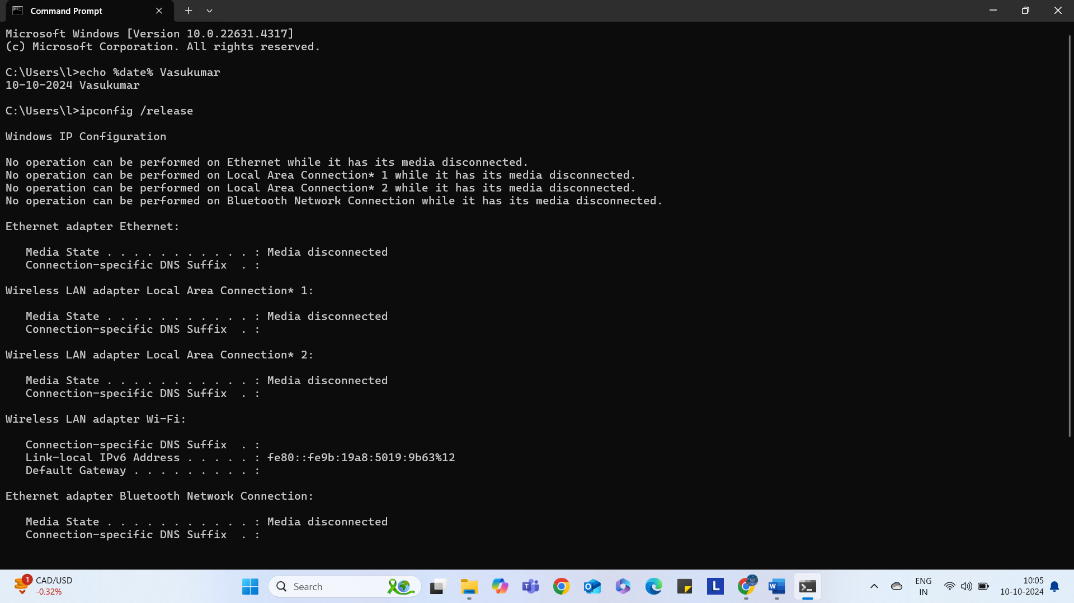

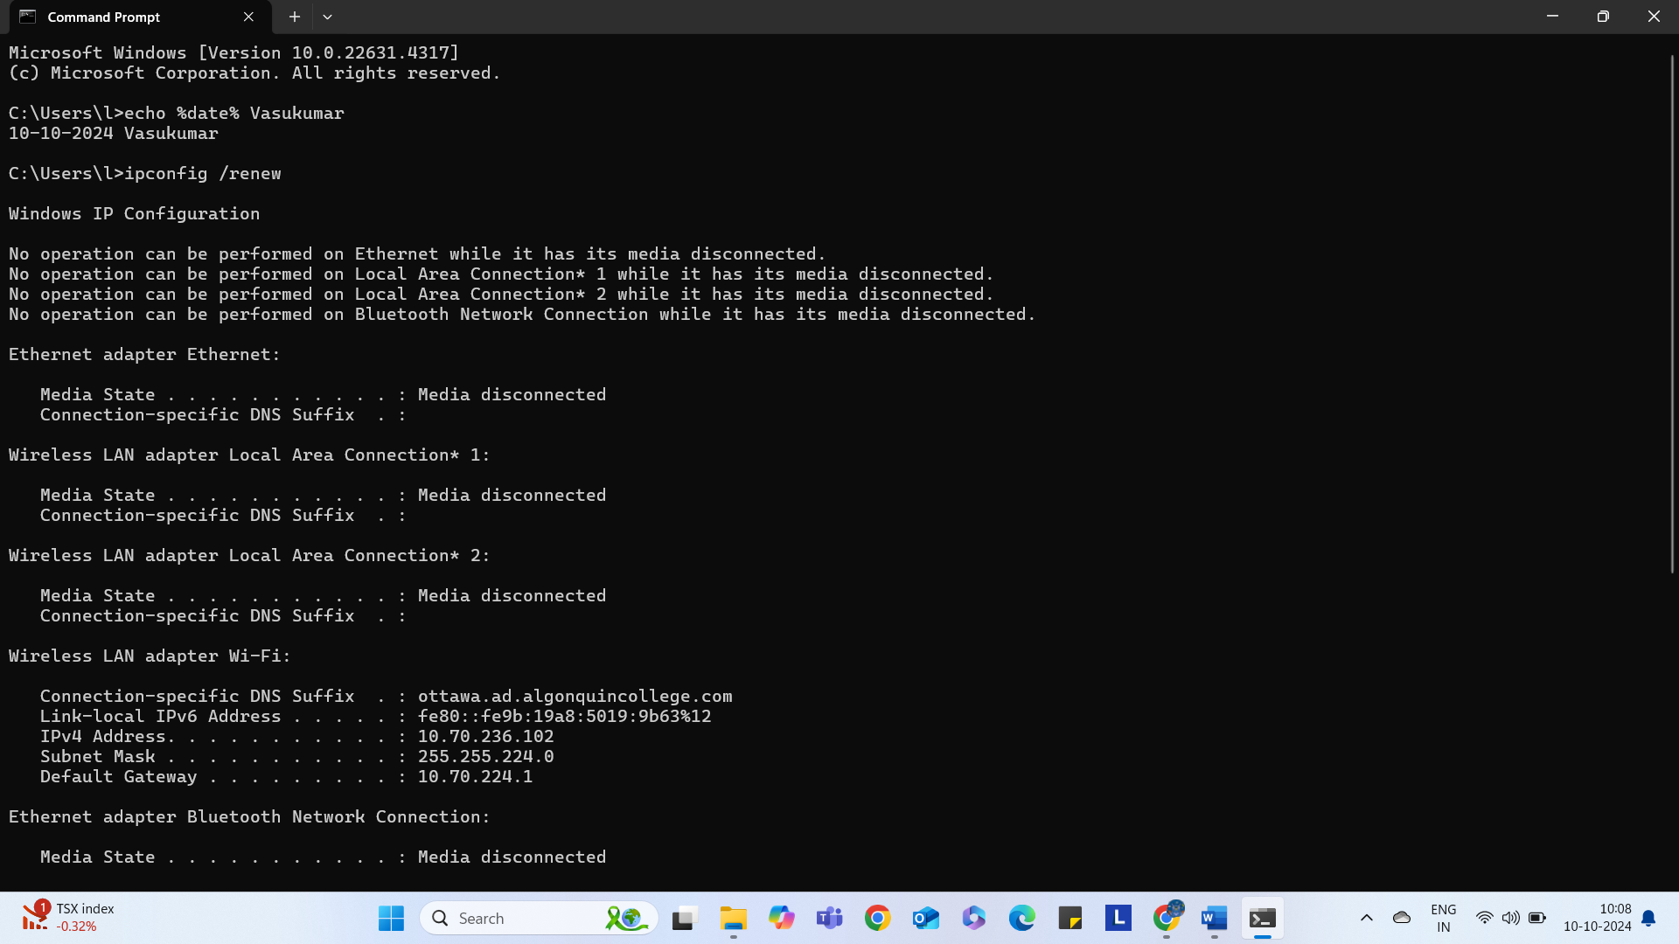

(2b) Screen shots showing use of net start and net stop as requested
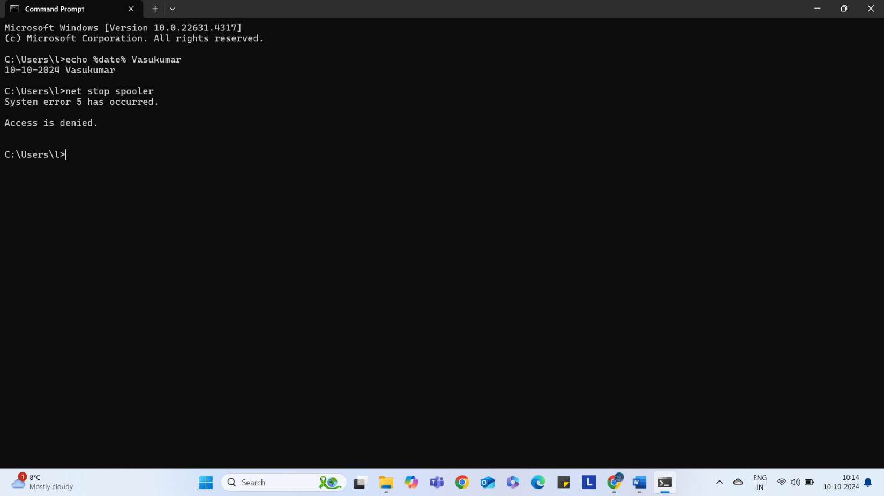

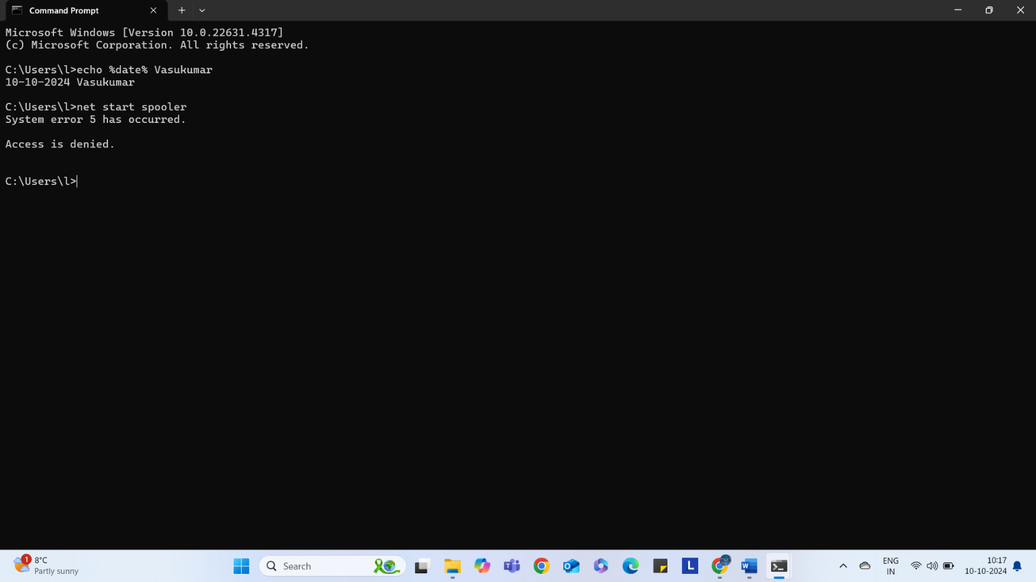

Part 3 Managing files (2 marks)
Copy and paste the output from the tree command here:
Folder PATH listing for volume Drive
Volume serial number is 863C-B3C1
E:.
+---Lab
| +---Lab Activity 00
| | CST8118_LA00_343_VasukumarPatel.docx
| | Lab Activity 00 (zero) Introduction to Lab.docx
| |
| +---Lab Activity 01
| | CST8118_LA01_343_VasukumarPatel.docx
| | Lab Activity 01 wi-fi, installs, passwords, licenses (24F)1.docx
| | macOSSonoma.pdf
| |
| +---Lab Activity 02
| | CST8118_LA03_343_Vasukumar.docx
| | Lab Activity 02 Managing Files, Updates and Antivirus (24F)_V2.docx
| |
| +---Lab Activity 03
| | CST8118_343_Lab3_Part1_Vasukumar_Patel.docx
| | CST8118_343_Lab3_Part2_Vasukumar_Patel.docx
| | Lab Activity 03 Computer Hardware and Computer Maintenance(24).docx
| |
| \---Lab Assignment 1
\---Lecture
+---Additional Learning Resources
| Citations and References in Computer Programming_V1.docx
| Study Tips for students.docx
|
+---Course Information
| CST8118 Weekly Schedule (CSI) Fall 2024 DRAFT_V3.docx
|
+---Discussion
| Computer Essential Discussion 1.docx
| Discussion 01 (1).docx
|
+---Lecture Materials
| +---Week 2 - September 9th 2024
| | CST8118 Course Introduction Section 340- (24F).pptx
| | CST8118 Passwords.pptx
| | CST8118 Professional Organizations.pptx
| | CST8118 Software Overview.pptx
| | ITSAP.30.032-best-practices-passphrases-passwords.pdf
| |
| +---Week 3 - September 16th, 2024
| | Algonquin College InfoSec Home.docx
| | Common file extensions found in Windows 10.docx
| | CST8118 Software Overview.pptx
| | CST8118 Windows and Antivirus Updates.pptx
| | CST8118_File Types and Attributes.pptx
| | CST8118_Malware.pptx
| | CST8118_Spam_Scams_Phishing.pptx
| | Week 2 How-To Windows, Antivirus Updates.docx
| |
| +---Week 4 - September 23rd, 2024
| | CST8118 Central Processing Unit (CPU).pptx
| | CST8118 Computer Drive Storage.pptx
| | CST8118 Computer Expansion Ports.pptx
| | CST8118 Computer Memory.pptx
| | CST8118 Computer Systems.pptx
| | Week 03 Computer Hardware (Ports, Parts, Specs).docx
| | Week 03 Computer Hardware (Ports, Parts, Specs)_V2.docx
| |
| +---Week 5 - September 30th, 2024
| | CST8118 - Backup and Recovery_V2.pptx
| | CST8118 Basic Network Connectivity Troubleshooting, Dynamic & Static IP.pptx
| | CST8118 Computer Maintenance Tools.pptx
| | Making a Backup Plan (Company) In Class Activity Part 1.docx
| | Making a Backup Plan (Personal) In Class Activity Part 2 (Sample Answer).docx
| | Making a Backup Plan (Personal) In Class Activity Part 2.docx
| | Using Windows 10 File History.docx
| | Using Windows 11 File History.docx
| | Using Windows 7 Backup and Restore in Windows 10, 11.docx
| | Week 4 How to reset the windows printer spooler.docx
| |
| \---Week 6 October 7th, 2024
| 01 CST8118_ComputerBinaryOverflow.pptx
| 02 CST8118-IEEE-754 Standard_V2.pptx
| 02 Slide Set Example 1 (8.75) _V2.docx
| 02 Slide Set Example 2 (-0.5).docx
| 02 Slide Set Example 3 (-1.0625).docx
| 02 Slide Set example of 15.25.docx
| 02a example of 1.6.docx
| 03 CST8118-IEEE-756 Binary32 Overflow, Underflow, NaN.pptx
| 04 CST8118 Character codes_V2.pptx
| In Class Excerise Unicode Answers.docx
| In Class Excerise Unicode Questions.docx
| Unicode Optional Practice Answers.docx
| Unicode Optional Practice.docx
| Utf-8 Chart-1.pdf
|
\---Matthew O' Meara Teaching Schedule
Timetable for Matthew OMeara.docx

Part 4 Create a windows backup and restore file(s) from it (2 marks)
Screen shot of backup tool showing that a backup was created:
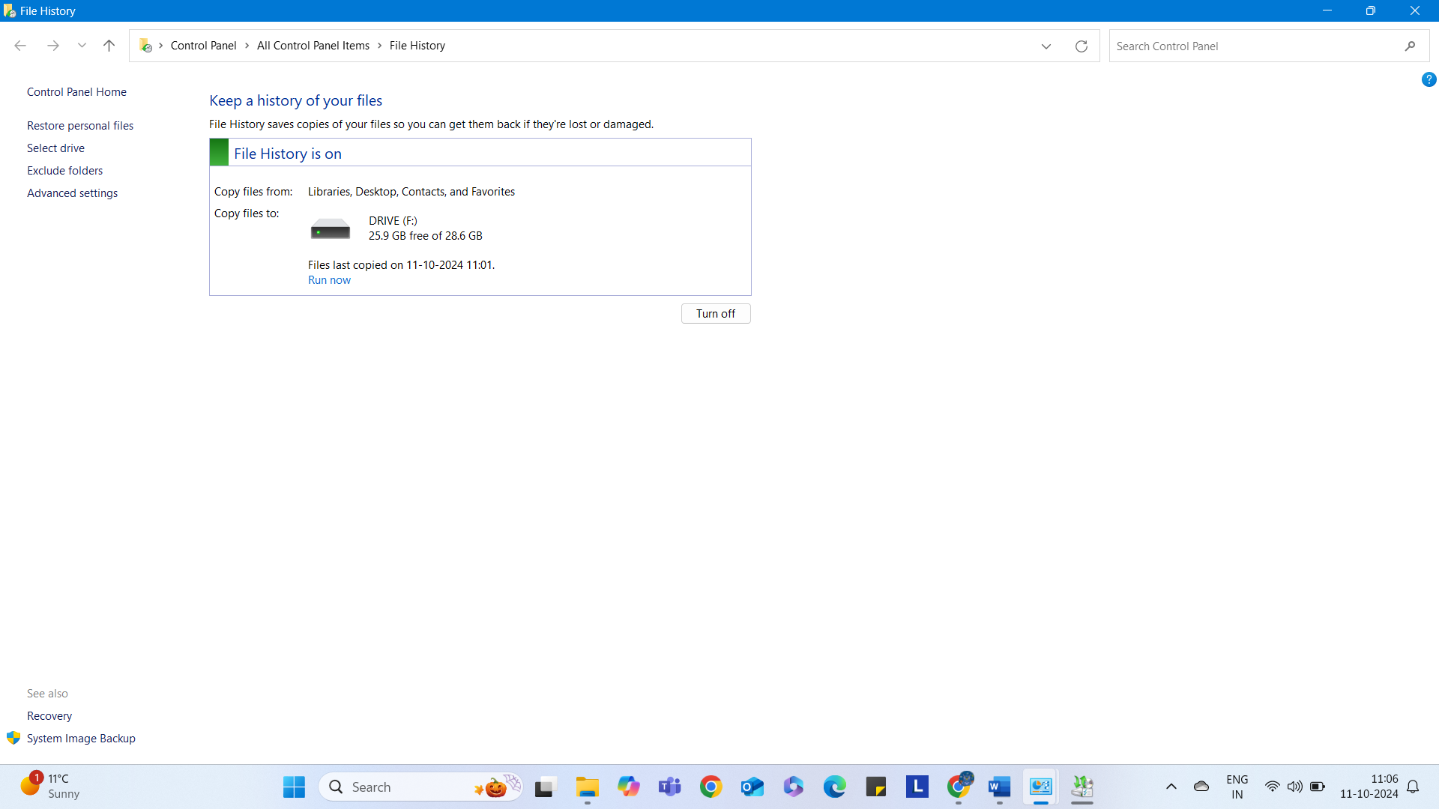

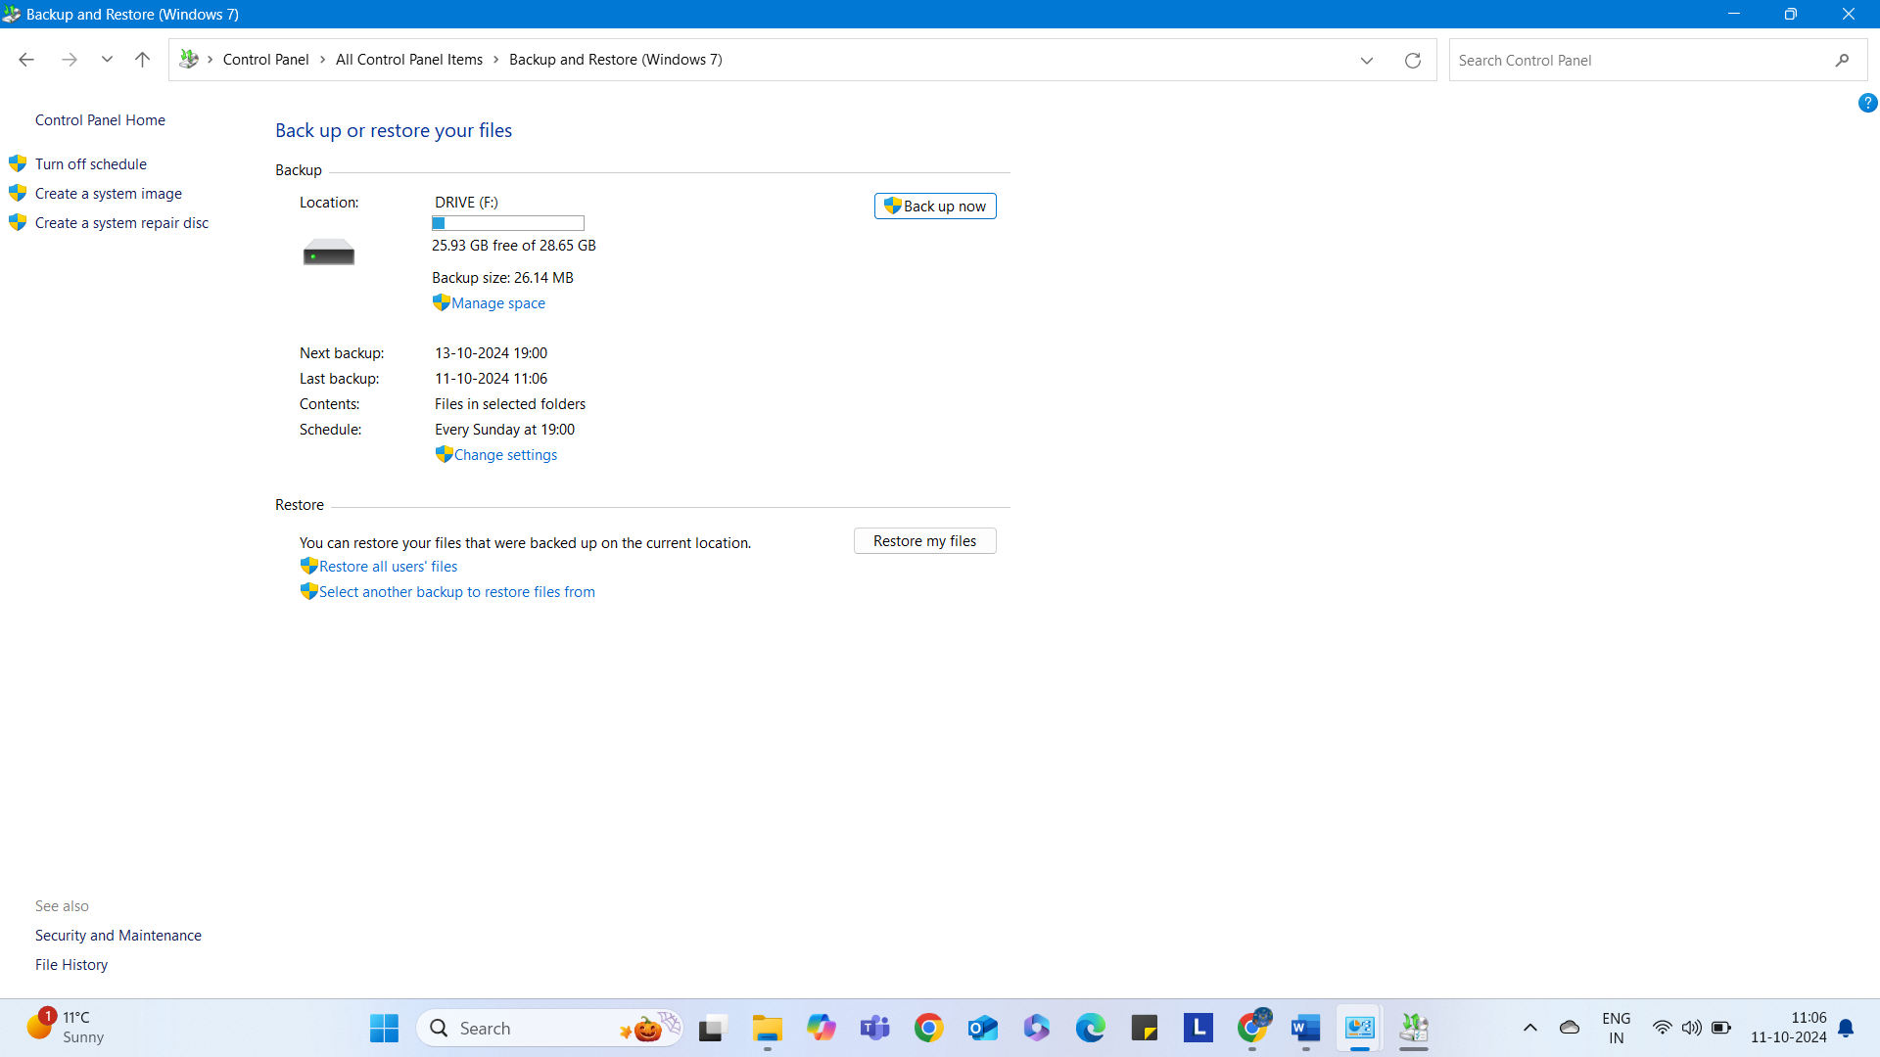

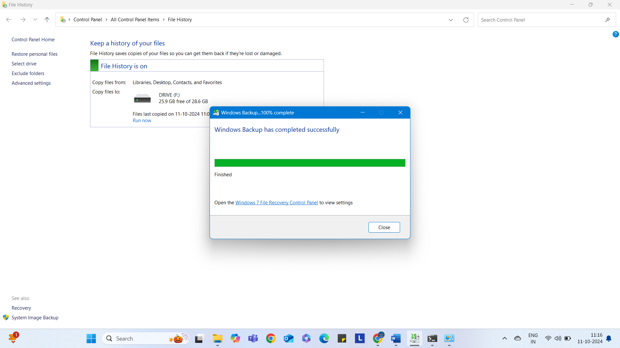

Part 5 List the specifications for a computer (1 mark)
Hyperlink to reference laptop used as source of computer specifications:

https://www.bestbuy.ca/en-ca/product/open-box-lenovo-thinkpad-t14-g4-ryzen-7-7840u-5-1-ghz-16gb-lpddr5x-512gb-ssd-14-fhd-touch-3-years-support/17940960
Computer Specifications as requested:
- The CPU name, number and types of cores, and cache sizes.
- Name: AMD Ryzen 7 PRO
- Number: 7840U
- Cores: 8-Cores 16-Threads
- Cache Sizes: 16 MB L3

- The amount of RAM and the type (DDR4/DDR5)
- Amount: 16GB
- Type: LPDDR5X
- The secondary storage, drive(s) and types (mechanical / solid state) and storage capacities.
- 512GB SSD
- The graphics processor name, model number, and amount of video memory.
- Name: AMD Radeon
- Model Number: 780M
- Amount of video memory: it shares with system memory because it is an integrated GPU.

- A list of the computer ports.
- USB-A
- USB-C
- HDMI
- Ethernet
- 3.5mm jack

